**Designer Criteria**

Topic: -

Community-Based Sustainable Transportation App

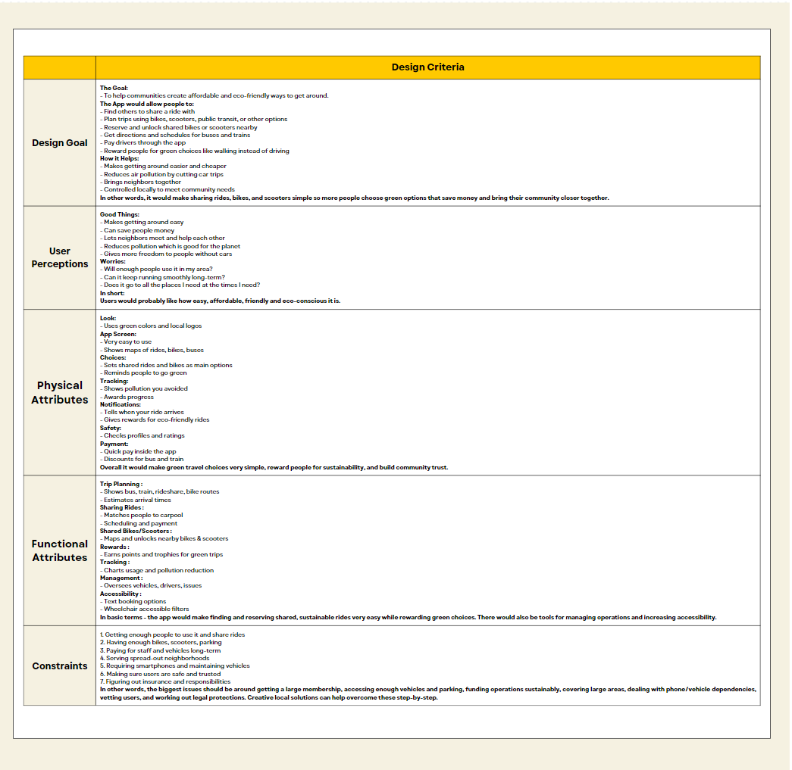

I designed a possible community-based sustainable transportation app focused on promoting affordable and eco-friendly mobility options. The goal would be enabling communities to share rides, bikes, scooters, and public transit seamlessly. Key features could include multi-modal trip planning, carpool scheduling, micromobility reservations, incentives for green trips, usage analytics, and an admin oversight portal. Benefits may encompass savings in costs and emissions, building social capital, and local control of assets. From a user perspective, the convenience, cost advantages, ability to meet neighbors, lowered environmental impact, and increased independence without owning cars would likely be welcomed. But questions around attaining a critical mass of engaged users and sustaining reliable operations would need addressing. Factors like branding, intuitive interfaces, proactive nudges, tracking personal contributions, safety verifications, and frictionless payments could further facilitate adoption. Operationally, the major constraints could involve acquiring vehicles and parking spots; achieving financially self-sufficient scale; geographic coverage challenges in sprawling regions; dependencies on consumer hardware and vehicles; authenticating users; and clarifying insurance liabilities. Creative partnerships, community organizing, appropriate pricing strategies and gradual expansion might help overcome these limitations. In summary, a thoughtfully localized and incentivized application facilitating shared mobility and transit could yield dividends in sustainability, affordability, and social connection. But for success, concerns around scaling participation, funding operations, managing assets, and user experience would need resolution through well-designed technological and community solutions.

**Navya Shah**

**11th A.I**